Book

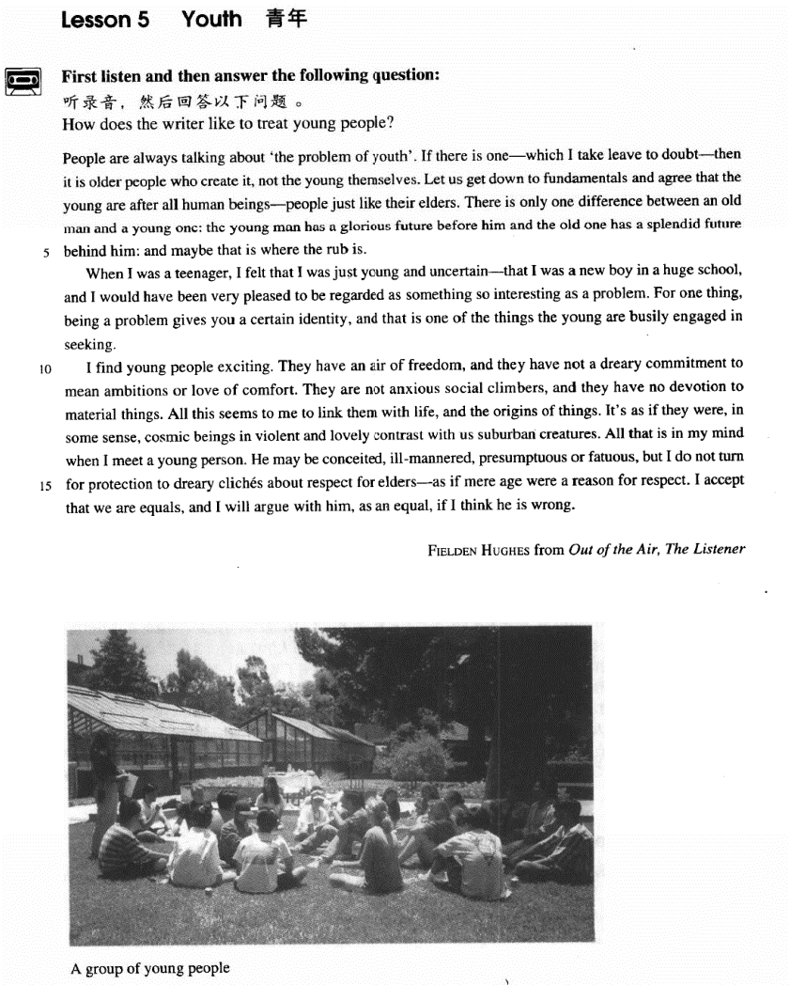

课文

People are always talking about 'the problem of youth'.

人们总是在谈论“青年问题”。

If there is one -- which I take leave to doubt -- then it is older people who create it, not the young themselves.

如果这个问题存在的话 -- 请允许我对此持怀疑态度 -- 那么，这个问题是由老年人而不是青年人造成的。

Let us get down to fundamentals and agree that the young are after all human beings -- people just like their elders.

让我们来认真研究一些基本事实：承认青年人和他们的长辈一样也是人。

There is only one difference between an old man and a young one: the young man has a glorious future before him and the old one has a splendid future behind him: and maybe that is where the rub is.

老年人和青年人只有一个区别：青年人有光辉灿烂的前景，而老年人的辉煌已成为过去。问题的症结恐怕就在这里。

When I was a teenager, I felt that I was just young and uncertain -- that I was a new boy in a huge school, and I would have been very pleased to be regarded as something so interesting as a problem.

我十几岁时，总感到自己年轻，有些事拿不准 -- 我是一所大学里的一名新生，如果我当时真的被看成像一个问题那样有趣，我会感到很得意的。

For one thing, being a problem gives you a certain identity, and that is one of the things the young are busily engaged in seeking.

因为这至少使我得到了某种承认，这正是年轻人所热衷追求的。

I find young people exciting.

我觉得年轻人令人振奋，

They have an air of freedom, and they have not a dreary commitment to mean ambitions or love of comfort.

他们无拘无束。既不追逐卑鄙的名利，也不贪图生活的舒适。

They are not anxious social climbers, and they have no devotion to material things.

他们不热衷于向上爬，也不一味追求物质享受。

All this seems to me to link them with life and the origins of things.

在我看来，所有这些使他们与生命和万物之源联系在了一起。

It's as if they were in some sense cosmic beings in violent and lovely contrast with us suburban creatures.

从某种意义上讲，他们似乎是宇宙人，同我们这些凡夫俗子形成了强烈而鲜明的对照。

All that is in my mind when I meet a young person.

每逢我遇到年轻人，脑子里就想到

He may be conceited, ill-mannered, presumptuous or fatuous, but I do not turn for protection to dreary cliches about respect for elders -- as if mere age were a reason for respect.

这些年轻人也许狂妄自负，举止无理，傲慢放肆，愚昧无知，但我不会用应当尊重长者这一套陈词滥调来为我自己辨护，似乎年长就是受人尊敬的理由。

I accept that we are equals, and I will argue with him, as an equal, if I think he is wrong.

我认为我和他们是平等的。如果我认为他们错了，我就以平等的身份和他们争个明白。

词汇讲解

### leave

* **leave** [li:v] n. 允许，许可

**leave** n. permission 允许，许可（一般用于固定搭配）

* He did it without my **leave**.
* The senator asked **leave** to take the floor.

**I take leave to do sth.** 请允许我做某事

* **I take leave to** say / doubt / think …

**【扩展】【近似词组】**表达“**请允许我**”：

**forgive me for doing**

* **Forgive me for saying** so, but what you said is nonsense.

**I take the liberty of doing**

* **I take the liberty of asking** you a question.

**I venture to do**

* **I venture to say** that you are making a dangerous mistake.

### fundamentals

* **fundamentals** [fʌndə'mentlz] n. 基本原理，基本原则

**fundamentals** n. **英文解释：**basic rules, ideas or principles 基本原理，基本原则

* the **fundamentals** of philosophy / economics

**【扩展】【近似词组】**表达“**基本原理，基本原则**”：

**the basics**

**the rudiments**

**the first principles**

**【同根词】**

**fundamental** adj. basic, essential 根本的

* the **fundamental** difference
* the **fundamental** cause of the problem

### glorious

* **glorious** ['ɡlɔ:riəs] adj. 光辉灿烂的，荣耀的，辉煌的
* a **glorious** achievement
* All the Chinese compatriots should take concerted efforts to create a **glorious** future of the Chinese nation.

**【近似词】**表达“ **光辉灿烂的**”：

a **rosy** / **brilliant** / **splendid** / **magnificent** future

**【同根词】**

**glory** n. 光荣，荣誉；赞颂

* glory days 光辉岁月

### rub

* **rub** [rʌb] n. 难题，困难，困境

**rub** n. **英文解释：**a problem or difficult situation 难题，困难，困境

* Here is the **rub**. 这就是问题所在
* That’s where the **rub** is.

**含义2：**v.摩擦

**rub sb. the wrong way** 让某人生气

* **托福听力真题：**

A. She has a negative impression of him.

B. She sees nothing new about him.

C. She thinks he gave her the wrong directions.

D. She doesn’t know him as well as she would like to.

* M: what do you think of our new economics instructor?
* W: I don’t know. Something about him **rubs me the wrong way**.
* Q: what does the woman say about the instructor?
* Answer: (A) She has a negative impression of him. rub sb. the wrong way

**【近义词组】**表达“让某人生气”：

**get on one’s nerves**

* **托福听力真题：**

A. The man shouldn't have invited her roommate to the meeting.

B. Her roommate was unable to attend the meeting.

C. Her roommate is unreliable about delivering messages.

D. She forgot about the time change.

* M: Why did you come to the meeting late? I left a massage with your roommate about the time change.
* W: She has a very short memory and it really **gets on my nerves** sometimes.
* Q: What does the woman imply?
* Answer: (C) Her roommate is unreliable about delivering messages.

### commitment

* **commitment** [kə'mɪtmənt] n. 信奉，信仰；承诺

**含义1：**信奉，信仰；

**commitment *to* sth.** 对…的信仰

* **have a sincere commitment** *to* religion / communism

**含义2：**承诺

***make* a commitment to do …** 做出承诺

* She promised to stand by him, and once you **make that commitment** you have to see it through.

***honor / fulfill* one’s commitment** 履行承诺

* We must ***honor* our commitments *to***small nations.
* The President of the United States has **reiterated the U.S. commitment *to***the Three Sino-U.S. Joint Communiqués.

### devotion

* **devotion** [dɪ'vəʊʃn] n. 热爱

**devotion *to* sb. / sth.** 对…的热爱（强调奉献精神）

**【近义词组】**表达“**爱**”：

**love** （没有场合限制）

**affection** （慈爱）

* parental **affection**
* maternal / paternal **affection**

**affectionate** 充满柔情的、慈爱的

**infatuation** （略贬义）过分的迷恋

* Their **infatuation** with each other won’t last.

### cosmic

* **cosmic** ['kɒzmɪk] adj. 宇宙的

**【同根词】**

**cosmos** n. 宇宙

**【辨析】【形近词】**

**comic** n. 连环漫画；喜剧演员；滑稽人物 adj. 喜剧的；滑稽的；有趣的

**comet** n. [天] 彗星

**cosmetics** n. 化妆品 （放在瓶子里的）

**make-up**  n. 化妆品 （涂在脸上的）

* She doesn’t wear **make-up**.
* She doesn’t wear cosmetics. X错误搭配

**【辨析】**

**universal** adj. 普遍的；通用的

* Certain funny situations have a **universal** appeal.

### suburban

* **suburban** [sə'bɜ:bən] adj. 郊区的；见识不广的，偏狭的

**【扩展】**

**suburban** adj. 郊区的；见识不广的，偏狭的

**provincial** adj. 省的；地方性的；偏狭的

**rural** adj. 农村的，乡下的；田园的，有乡村风味的

**pastoral** adj. 牧师的；牧人的；田园生活的；乡村的

**urban** adj. 城市的；住在都市的

**metropolitan** adj. 大都市的；大主教辖区的；宗主国的

**metropolis** n. 大都市；首府；重要中心

**cosmopolitan** adj. 世界性的；世界主义的，四海一家的

**cosmopolis** n. 国际都市

课文讲解

# （第一段）

# People are always talking about 'the problem of youth'.

知识点（1）Lesson03- 02

**be always doing** （贬义）老是做某事

* He’**s always having** arguments with people.
* Our vicar **is always raising** money for one cause or another, but he has never managed to get enough money to have the church clock repaired.
* **4级真题：**

A. The woman would understand if she did Mary’s job.

B. The woman should do the typing for Mary.

C. The woman should work as hard as Mary.

D. The woman isn’t a skillful typist.

* W: Mary **is always complaining** about her job.
* M: Maybe if you try typing letters every day, you'd see what it's like.
* Q: What does the man mean?
* Answer: (A) The woman would understand if she did Mary’s job.

**【近似词组】**表达“**老是做某事**”：

**be forever doing** （贬义）

* He **is forever talking** about the friendly people, the clean atmosphere, the closeness to nature and gentle pace of living.

**be constantly / continually doing sth.** （贬义）

* Your behavior reflects on me, and I can't do my job if you**'re constantly humiliating** me.
* **Constantly**? Aside from today, give me one example.

**keep (on) doing sth.** （贬义）

* From the moment he arrived there, he **kept on pestering** his doctor to tell him when he would be able to go home.
* In the process, he enjoyed himself thoroughly and **kept telling** everybody how much he hated hospitals.

**do sth. all the time / time and time again / with monotonous regularity / ad nauseam**（贬义）

* The same old favorites **recur** year in year out **with monotonous regularity**.
* **托福听力真题：**

A. He is tired of waiting for assistance.

B. He doesn't have to ask his friends for help.

C. His foot hurts too much to walk.

D. He doesn't like to bother people.

* W: I thought the doctor said you should stay off your foot until the swelling goes down.
* M: She did. It just makes me uncomfortable to **ask** my friends to wait on me **all the time**.
* What does the man mean?
* Answer: (D) He doesn't like to bother people.

# If there is one -- which I take leave to doubt -- then it is older people who create it, not the young themselves.

**语法分析：**

If there is one*—which I take leave to doubt（插入语，表怀疑）—**（if... 条件状语从句）*then it is（强调句） older people who（强调的是人，用who） create it, not the young themselves.

知识点（1）

* … which I take leave to doubt *（插入语，表怀疑）*…

**【近义词组】**表达怀疑：

**at all** 在疑问句、条件状语从句中标识“真的…，对此不大相信”

* Do you know him **at all**? 你真的认识他吗？
* He will come before dinner if he comes **at all**.
* **课文写法替换：**
* If there is one **at all**, then it is older people who create it, not the young themselves.

知识点（2）复习

语法：强调句

**it is / was … that / who …**

知识点（3）

**语法**：**if … then…**（then是副词、非必须，与if从句呼应，使if从句连冠感更强；往往用于if从句和主句之间有其他比较长的成分）

知识点（4）【课文仿写】

**【课文句型提炼】**

**If …… —which I take leave to doubt—then it is … that / who …, not …**

如果…对此我不能苟同，那么是某人会怎么样…，而不是…

* **造句:** 如果真有天堂的话（请允许我对此表示怀疑），那么也是有钱有势的人（the rich and powerful）去的地方, 而不是穷人自己可以去的地方。
* If there is heaven—which I take leave to doubt—then it is the rich and powerful who can enter, not the poor themselves.

# Let us get down to fundamentals and agree that the young are after all human beings -- people just like their elders.

**语法分析：**

Let us get down to fundamentals and agree（承认） **that** the young are after all human beings—*people just like their elders**（同位语）*. （**that**… 宾语从句）

知识点（1）

**get down to sth. / doing** **英文解释：**to start doing sth. seriously开始认真严肃的做某事

* Let’s **get down to** business.
* Let’s **get down to** discussing the details.

知识点（2）

**agree** v. **accept** / **admit** / **acknowledge** / **recognize** / **concede** 承认

# There is only one difference between an old man and a young one: the young man has a glorious future before him and the old one has a splendid future behind him: and maybe that is where the rub is.

**语法分析：**

There is only **one difference** between an old man and a young one: the

young man has a glorious future before him and the old one has a splendid future behind him（**one difference**的同位语）: and（大并列） maybe that is *where the rub is（… 表语从句）*.

知识点（1）

**just / merely / no more than + one difference** 只有唯一的区别

**a single / solitary difference** 唯一的

知识点（2）

**写作：antithesis 对比**；结构相同、意思相对；修辞可以增强表达效果

* … the young man has a glorious future before him and the old one has a splendid future behind him …
* When poverty comes in at the door, *love leaps out at the window*.
* 翻译（对仗）：贫穷跨们而入、爱情破窗而出
* A mother takes twenty years to make a man of her boy, and another woman takes twenty minutes to make a fool of him.
* **中文对仗举例：**
* 谦受益、满招损
* 人有悲欢离合、月有阴晴圆缺
* 卑鄙是卑鄙者的通行证、高尚是高尚者的墓志铭
* 文竹、武松
* 孙行者、祖冲之
* 三星白兰地、五月黄梅天
* 一品天青带、六味地黄丸

知识点（3）

**that is where…** 那就是

* **That’s where** you and I differ.
* **That’s where** I draw the line. 这种事坚决不做

# （第二段）

# When I was a teenager, I felt that I was just young and uncertain -- that I was a new boy in a huge school, and I would have been very pleased to be regarded as something so interesting as a problem.

**语法分析：**

When I was a teenager（时间状语从句）, I felt **that I was** just young and uncertain—that I was a new boy in a huge school（—that... 解释前面的表语从句） （**that I was**… 表语从句）, and I would have（虚拟语气） been very pleased to be regarded as something so interesting as a problem（形容词短语做后置定语，修饰something）. （to be …不定式可以看作条件状语）

知识点（1）

**teenager** / **teen** n. 青少年

**in one’s teens**

* When I was **in my teens**, …

**【扩展】**

**adolescent** n. & adj. n. 青少年 adj. 青春期的；未成熟的

* When I was an **adolescent**, …
* my **adolescent** daughter

**adolescence** n. 青春期

**juvenile** 少年的；未成年的

* **juvenile** delinquency
* **juvenile** delinquent

知识点（2）

**写作：**暗喻

huge school 比喻“society 社会”

**写作：**明喻

* The **society** is like a **huge school**.

知识点（3）复习

**【近义词组】**表达“**把A看作B**”：

**regard / see / count A as B**

**think of / look on / conceive of A as B**

**consider A (to be) B**

* If you lived in the Mediterranean, for instance, you would **consider octopus a great delicacy**.

**deem / reckon A to be B**

**be recognized / acknowledged as …** 被公认为是…

* Heifetz **was recognized / acknowledged as** the greatest violinist of the 20th century.

知识点（4）

**本句话总结：**Being a problem is better than being a nobody.

# For one thing, being a problem gives you a certain identity, and that is one of the things the young are busily engaged in seeking.

**语法分析：**

*For one thing*（介词短语做状语，“原因之一是”，引出原因）, being a problem gives you a certain identity, and that is one of the things the young are busily engaged in seeking（定语从句）.

知识点（1）

**for one thing … for another …** 原因之一是… 另一个原因是…

* **对话：**
* "Why won't you come to New York with me?"
* "**For one thing**, I don't like flying, **and for another**, I can't afford it."

**【复习】**

**on the one hand ... on the other (hand) …** 一方面是… 另一方面是…（表转折）

* **On the one hand** I'd like a job which pays more, **but on the other (hand)** I enjoy the work I'm doing at the moment.

**not that …, but that …** 不是因为… 而是因为…（平行结构、要求对仗）

* **Not that** I love Caesar less, **but that** I love Rome more. —— Shakespeare ‘Julius Caesar’
* **Not that** I love you less, **but that** I love liberty more.
* **Not that** I love my teacher less, **but that** I love truth more.

**It is not that … but (that) …** 不是因为… 而是因为…

* **It was not that** I actually remembered anything at all. **But** my father had described over and over again what we should see at every milestone, after leaving the nearest town, …
* **考研英语（英译汉）：**
* **It is not that** the scales in the one case, and the balance in the other, differ in the principles of their construction or manner of working; **but that** the latter is a much finer apparatus and of course much more accurate in its measurement than the former.
* 翻译：这不是因为在第一种磅秤与另一种天平的构造原理或工作方式不同； 而是因为后者是一种更精密的多的仪器，当然在测量上比前者更准确。

知识点（2）Lesson04-02

**be engaged in sth. / doing** 忙于某事

* How many spiders **are engaged in** this work on our behalf?

# （第四段）

# I find young people exciting.

知识点（1）

**find** （书面语）= think、**feel**

# They have an air of freedom, and they have not a dreary commitment to mean ambitions or love of comfort.

知识点（1）

**air** 风度、气质、气场

知识点（2）

**dreary** = boring、monotonous

# They are not anxious social climbers, and they have no devotion to material things.

# All this seems to me to link them with life and the origins of things.

**语法分析：**

All this seems to me（插入语） to link them with life（with的宾语） and the origins of things（with的宾语）.

# It's as if they were in some sense cosmic beings in violent and lovely contrast with us suburban creatures.

**语法分析：**

It's **as if** they were（虚拟语气）, in some sense（插入语，某种意义来说）, cosmic beings *in violent（强烈地） and lovely contrast with us suburban creatures（介词短语做比较状语）*. （**as if**… 表语从句）

知识点（1）

*虚拟语气知识点（2）*Lesson03-33、Lesson03-77

**语法：as if** / **as though** 从句中表达与事实相反或可能性很小时，可以用虚拟语气。与现在事实相反用一般过去时（be 动词一般用 were），与过去事实相反用过去完成时，与未来趋势相反用 would / should / could / might + 动词原形

* Don’t act **as if** you ***were*** the only pebble on the beach. 不要自视太高
* It is **as if** a single unimportant event ***set****(过去式，虚拟语气，与现在事实相反)* up a chain of reactions.
* **As if** this ***were****(过去式，虚拟语气，与现在事实相反)* not enough to reduce you to tears, your husband arrives, unexpectedly bringing three guests to dinner.
* I felt **as if** I ***had*** *stumbled(过去完成时，虚拟语气，与过去事实相反)* into a nightmare country, as you sometimes do in dreams.
* It looks as if it ***might****(虚拟语气，与未来趋势相反)* rain.

**注意**，**as if** / **as though**从句中虚拟语气为进行时的时候，一般都用were doing 的形式。

* 'Oh, that,' he said with a smile **as if** he ***were talking*** about an old friend.
* Suddenly, the knocking turned to a forceful banging, **as if** someone ***were hitting***the door with a metal rod. *(The Da Vinci Code)*
* It looks **as if** he ***were talking***to someone invisible.

知识点（2）

**in some sense** 在某种意义上来说

* I think he may be right **in some sense**.

**【扩展】【复习】**

**to some degree / extent** 某种程度上来说

* I agree with you **to some degree / extent**.

**in some measure** 在某种程度上来说

* The true value of a human being is determined primarily by the **measure** and the **sense** **in** which he has attained liberation from the self. ——Albert Einstein

知识点（3）

**be** 有；存在

**human being** 人类

**intelligent being** 智慧生物

**alien being** 外星人

* To **be**, or not to **be**: that is the question. ——William Shakespeare
* 生存、毁灭：这还是个问题
* I think therefore I **am**.—— René Descartes
* 我思顾我在
* **Being** *and Nothingness —*— Jean Paul Sartre
* 存在与虚无

知识点（4）

**【近义词组】**表达“**与…对比**”：

**in / by + contrast + to / with …**

**in / by + comparison + to / with …**

**compared to / with …**

# All that is in my mind when I meet a young person.

知识点（1）

**be *in* one’s mind** 记在心中

**【辨析】**

**be *on* one’s mind** 牵挂着

# He may be conceited, ill-mannered, presumptuous or fatuous, but I do not turn for protection to dreary cliches about respect for elders -- as if mere age were a reason for respect.

**语法分析：**

He may be conceited, ill-mannered, presumptuous or fatuous, but I do not turn *for protection* to dreary cliches about respect of elders（改变语序）—*as if mere age were（虚拟语气） a reason for respect（方式状语从句）*.

知识点（1）Lesson03-53

**非谓语动词做形容词**

**ill** adv. badly

* **ill**-treated animals
* **ill**-bred
* **ill**-advised
* **ill**-mannered
* **ill**-educated
* **ill**-tempered

**【反义】**

* **well**-bred
* **well**-advised
* **well**-informed
* **well**-intentioned
* Nor is it only the ignorant and **ill-educated** person who was such faith in the bottle of medicine.

知识点（2）

**turn to … for …** 向…（前者） 寻求…（后者）

* The child **turned to** his mother **for** comfort.
* The refugees **turned to** the embassy **for** protection.
* He had to **turn to** his brother **for** help, because his brother is the only person he could trust.
* He had to turn ***for*** *help（改变语序）* **to** his brother, the only person he could trust.（更简洁）

**【复习】**Lesson04-01、Lesson04-04改变语序

* The long hours in the office or the factory **bring** *with them as their reward*, not only the means of sustenance, but a keen appetite for pleasure even in its simplest and most modest forms.

知识点（3）

**age** n.老年；陈年；破旧；老化

* An idle youth, a needy **age**.

# I accept that we are equals, and I will argue with him, as an equal, if I think he is wrong.

**语法分析：**

I accept that we are equals（宾语从句）, and I will argue with him, *as an equal（插入语）*, if I think he is wrong（if... 条件状语从句）.

# （课文总结）

课文总结

**写作题材：Claim-Response Pattern**主张反应模式

**claim** 给出某人的观点

**response** 给出作者自己的响应，或支持、或反对、或半支持半反对

**reasons for response**  对理由进行分析解释

**relevant example(s)** 举出相关例子

**reaffirmation** 进一步强调加强作者的响应